**Lab 6 (Parallel Programming)**

**NAME:** ADITYA MISHRA

**REG. NO:** RA2111003011817

1. Write a program that uses multiple threads to solve the problem of finding the integer in the range 1 to 10000 that has the largest number of divisors, but for the range 1 to 100000. At the end of the program, output the elapsed time, the integer that has the largest number of divisors, and the number of divisors that it has.

import time

import threading

def count_divisors(n):

count = 0

for i in range(1, n+1):

if n % i == 0:

count += 1

return count

def find_largest_divisors(start, end, result):

max_divisors = 0

max_num = 0

for n in range(start, end+1):

divisors = count_divisors(n)

if divisors > max_divisors:

max_divisors = divisors

max_num = n

result.append((max_num, max_divisors))

if __name__ == '__main__':

num_threads = 4

chunk_size = 100000 // num_threads

results = []

start_time = time.time()

threads = []

for i in range(num_threads):

start = i * chunk_size + 1

end = start + chunk_size - 1

if i == num_threads - 1:

end = 100000

thread = threading.Thread(target=find_largest_divisors, args=(start, end, results))

threads.append(thread)

thread.start()

for thread in threads:

thread.join()

max_num, max_divisors = max(results, key=lambda x: x[1])

elapsed_time = time.time() - start_time

print(f"Elapsed time: {elapsed_time:.3f} seconds")

print(f"Number with max divisors: {max_num}")

print(f"Number of divisors: {max_divisors}")o

**Output-**

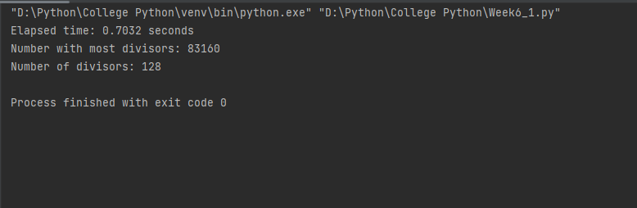

5) Write a multi processing program in which the first process prints odd numbers between

100 to 200. Second Process print the prime number. Between 200 to 300. And third process

generate Armstrong number between 100 to 300.

import multiprocessing

def is_prime(n):

if n <= 1:

return False

for i in range(2, int(n ** 0.5) + 1):

if n % i == 0:

return False

return True

def is_armstrong(n):

digits = [int(x) for x in str(n)]

num_digits = len(digits)

sum_of_powers = sum([x ** num_digits for x in digits])

return sum_of_powers == n

def print_odd_numbers():

for i in range(101, 200, 2):

print(i)

def print_prime_numbers():

for i in range(200, 300):

if is_prime(i):

print(i)

def print_armstrong_numbers():

for i in range(100, 300):

if is_armstrong(i):

print(i)

if __name__ == '__main__':

p1 = multiprocessing.Process(target=print_odd_numbers)

p2 = multiprocessing.Process(target=print_prime_numbers)

p3 = multiprocessing.Process(target=print_armstrong_numbers)

p1.start()

p2.start()

p3.start()

p1.join()

p2.join()

p3.join()

**OUTPUT:**

